**A Stellarium-Guided Tour of the Night Sky For Teachers**

1. Download the Stellarium software at <http://stellarium.org/> and install it on your device.
2. Open the software.
3. Fast forward through time until after sunset using the fast forward and play buttons at the bottom of your screen*.*
4. Turn off the atmosphere button. You should now have a clear view of the night sky.
5. Find the Milky Way and follow it over the sky by clicking and dragging.

**Navigation: Finding South**

1. Start by turning off cardinal points. The red compass points on the horizon should disappear.





1. Find the Southern Cross either by turning on constellation lines button (below) and finding the small cross or by using the search tool on the left of the screen (right) and searching up ‘Acrux’, the bottom star of the cross.

The Southern Cross may be located below the horizon, so you may need to turn off the ground button (below).



1. Once you have found the Southern Cross, you need to locate the two pointer stars. They will be two bright stars to one side called Alfa Centauri (Rigil Kentaurus) and Beta Centauri (Hadar). Use the search tool again if you are unsure.
2. 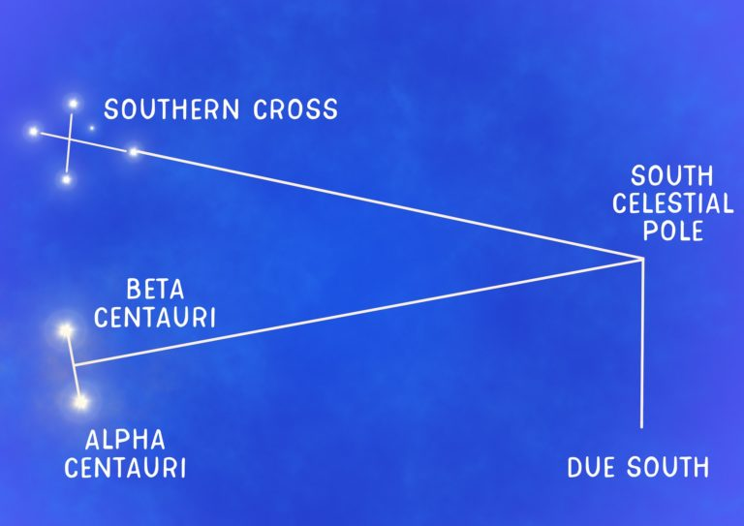The south celestial pole is the point which the entire sky appears to rotate around. Find this by drawing two imaginary straight lines. The first extends from the longest arm of the Southern Cross. The second extends from a perpendicular cross section of the two pointer stars. Where these two imaginary lines intersect is the south celestial pole. You can check by fast forwarding through time again, or turning on the equatorial grid button (below).



1. Make sure the ground button is back on. Draw an imaginary line from the south celestial pole straight down to the ground. You should have found due south. Check by turning cardinal points back on again.

**Orion – Greek Mythology and Aboriginal Connections**

To find Orion

1. Search for ‘Betelgeuse’, the star of his right shoulder.
2. Turn on constellation art (right).

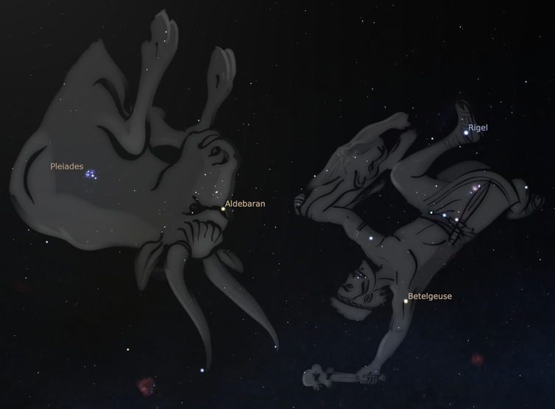

In Greek mythology, Orion was an excellent, yet boastful hunter who was eventually killed by a giant scorpion (the zodiac sign Scorpio). The gods placed the two on opposite sides of the sky to separate them but each night they chase each other across the sky. Orion is seen locked in a constant battle against a charging bull (the zodiac sign Taurus). In some representations, he wields the pelt of a lion and a club, in others, a sword and shield, or a bow and arrow.

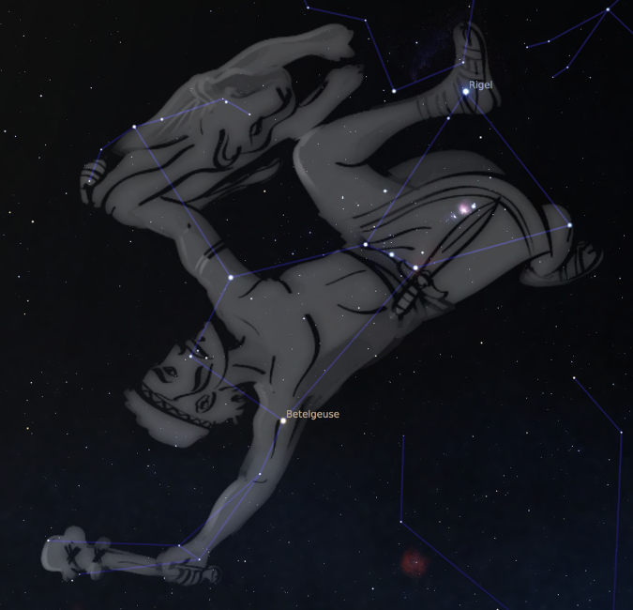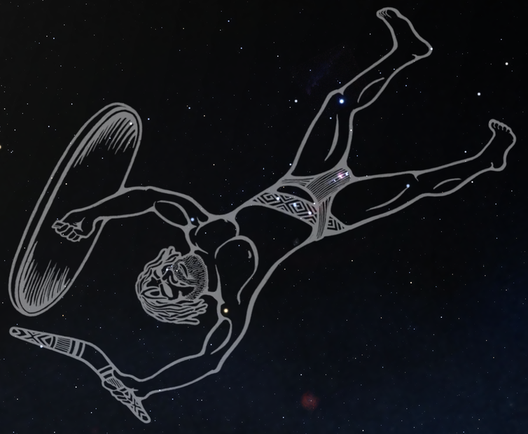

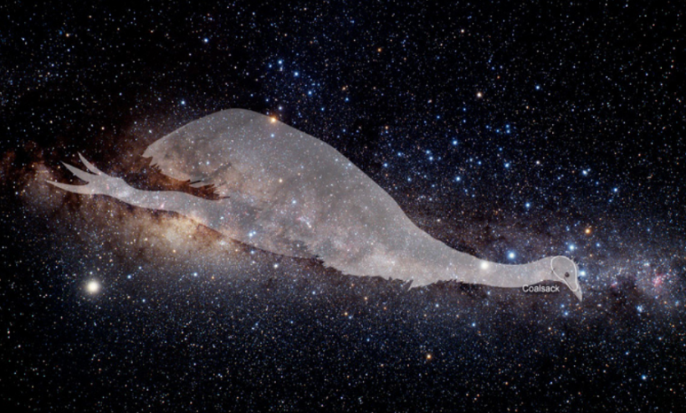There are great parallels between Greek and Aboriginal cultural interpretations of the stars considering the two arose on opposite sides of the world with no contact since their origins in Africa. In Aboriginal [Wiradjuri](https://en.wikipedia.org/wiki/Wiradjuri) cultures from south-east Australia, this cluster of stars is known as Baiame, the creator god and Sky Father in the dreaming. Here, he wields a boomerang and shield (upper-right). It is said that he hunts and chases the emu that appears in the haze of the Milky Way (right), but each night trips and falls over the horizon as the constellation sets, which is why he appears upside down.

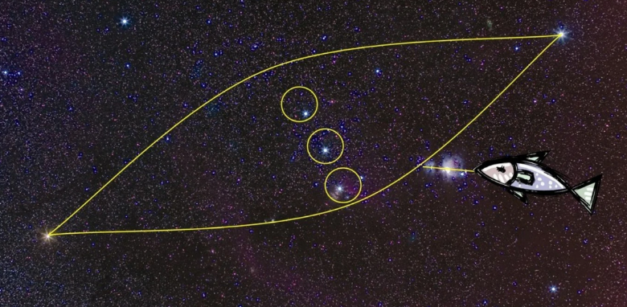When seen from an Australian vantage point, Orion is upside down, so the Yolngu people of north-eastern Arnhem Land saw three brothers and a canoe. They called this Djulpan, which is a prominent Aboriginal legend.

One day, three brothers decided to go fishing against the advice of their elders. It was storm season and far too dangerous. The three brothers ignored the warning and went anyway. They found themselves sitting in a canoe for hours catching nothing but kingfish, which is a problem as it's the totemic animal for their tribe. To eat it would be akin to cannibalism.

Eventually one of the brothers cracked and ate one, causing Walu, the Sun Woman, to become furious. Walu took the storm clouds and turned them into a whirlwind that lifted the boat up and cast the brothers into the sky where they remain today.

This story is an excellent example of the moral lessons engrained in astronomy storytelling. There's both a lesson about keeping sacred law, and paying heed to the words of elders. Not only that, but there's also a practical application. Djulpan is only visible from February to March, which is when the monsoon begins. That tells you it's no longer safe to go out and fish.

As there are many Aboriginal cultures, there are many more interpretations of various star clusters. Below are just a few examples.

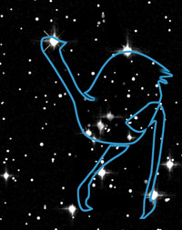

Orion representing an emu seen from a Southern hemisphere perspective (left) and orientated correctly for the image (right).

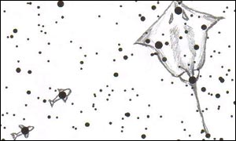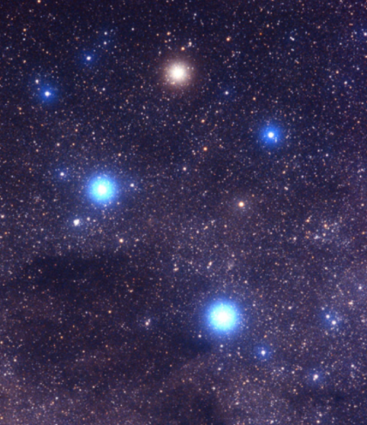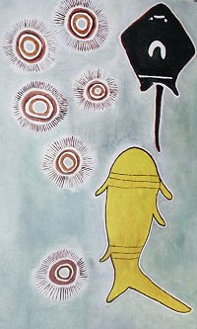In Arnhem Land, the Southern Cross is a shark chasing a stingray and the two pointer stars are smaller fish.

But for another group of Aboriginal people, it is a white ghost gum with two yellow-crested cockatoos.

**Zodiac Constellations**

October is the time to see Libra and Scorpio, but using Stellarium, we can see all of the zodiac constellations. They go in a ring across the sky. The students will probably want to see their own star sign.

1. Start by turning on the constellation art button (below).



1. Look at the Southern part of the sky just above the horizon. Turn off the ground button (below) and follow the constellation pictures.

You can identify the Zodiac constellations based on their pictures:

Libra – Set of scales

Scorpio – Scorpion

Sagittarius – Centaur with a bow and arrow

Capricorn – Ram with fish tail

Aquarius – Man pouring water from a vase

Pisces – Two fish joined by a V-shaped line

Aries – Ram

Taurus – Bull

Gemini – Twins

Cancer – Crab

Leo – Lion

Virgo – Woman

References

Allegretti, D. 2014. *How Aboriginal Australians Saw the Stars.* Vice Media Group. <https://www.vice.com/en/article/gq894b/australia-has-a-night-sky-youve-never-seen>

**Hamacher, D. W. 2017. *Kindred skies: ancient Greeks and Aboriginal Australians saw constellations in common.* The Conversation Media Group. https://theconversation.com/kindred-skies-ancient-greeks-and-aboriginal-australians-saw-constellations-in-common-74850**

|  |  |
| --- | --- |
| Constellation Lines |  |
| Constellation Art |  |
| Equatorial Grid |  |
| Ground |  |
| Cardinal Points |  |
| Atmosphere |  |
| Play Normal Speed and Fast Forward |  |